**Probability** **and Statistics**

**Lab 06  
IT24100860**

**Fernando S.K**

**Exercise**

1. **i)** Binomial distribution (*n*=50,*p*=0.85)

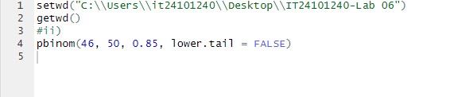**ii)**

1. i) Number of customer calls received in an hour  
   ii) Poisson distribution

iii)

